**The Pythagorean Property**

**Exercise 1**

*Read these words.*

|  |  |
| --- | --- |
| stretch вытягивать(ся), растягивать(ся)  rope веревка, шнур  unit ['ju:nit] 1. единица;  2. единица измерения  dash черточка, штрих | several ['sevrәl] несколько  relationship [ri'leiʃәnʃip] взаимоотношение, соотношение  'credit *n* 1. доверие, вера; 2. заслуга; *v* приписывать (заслугу)  area площадь |

**Notes**

1. Pythagoras... is credited with – Пифагору... приписывают заслугу
2. to begin with – изначально, для начала

**Exercise 2**

*Ask questions using the question-words in brackets.*

1. Pythagoras succeeded in stating this relationship, (in what way). 2.You have to stretch these ropes, (why). 3. I know several proofs of this theorem, (who). 4. This region of the area is dashed, (why). 5. Two right triangles are to be constructed in the given region, (how). 6. The sum of the four triangles makes the total area of this square, (why). 7. To begin with, we shall divide the entire area into several equal units, (what). 8. The proof of the theorem stated seemed rather complicated, (the proof of which theorem).

**Exercise 3**

*a) Read the text below;*

*b) Analyze the sentences you find difficult to understand and translate them. Pay special attention to sentences 1, 2, 7, 8, 9, 16, 21, 24.*

**The Pythagorean Property**

1. The ancient Egyptians discovered that in stretching ropes of lengths 3 units, 4 units and 5 units as shown below, the angle formed by the shorter ropes is a right angle. 2. The Greeks succeeded in finding other sets of three numbers which gave right triangles and were able to tell without drawing the triangles which ones should be right triangles, their method being as follows. 3. If you look at the illustration you will see a triangle with a dashed interior. 4. Each side of it is used as the side of a square. 5. Count the number of small triangular regions in the interior of each square. 6. How does the number of small triangular regions in the two smaller squares compare with the number of triangular regions in the largest square? 7. The Greek philosopher and mathematician Pythagoras noticed the relationship and is credited with1 the proof of this property known as the Pythagorean Theorem or the Pythagorean Property. 8. Each side of a right triangle being used as a side of a square, the sum of the areas of the two smaller squares is the same as the area of the largest square.

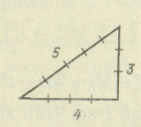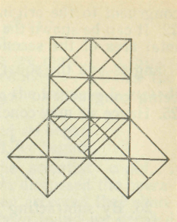

**Proof of the Pythagorean Theorem**

9. We should like to show that the Pythagorean Property is true for all right triangles, there being several proofs of this property. 10. Let us discuss one of them. 11. Before giving the proof let us state the Pythagorean Property in mathematical language. 12. In the triangle above, *с* represents the measure of the hypotenuse, and *a* and *b* represent the measures of the other two sides. 13. If we construct squares on the three sides of the triangle, the area-measure will be *a2, b2* and c2. 14. Then the Pythagorean Property could, be stated as follows: *c2 = a2+b2.* 15. This proof will involve working with areas. 16. To prove that *c2=a2+b2* for the triangle above, construct two squares each side of which has a measure *a*+*b* as shown above.

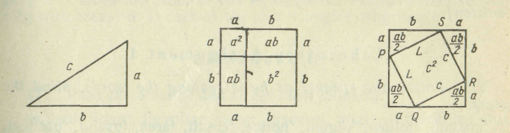

17. Separate the first of the two squares into two squares and two rectangles as shown. 18. Its total area is the sum of the areas of the two squares and the two rectangles.

*A = a2+2ab+b2.*

19. In the second of the two squares construct four right triangles. 20. Are they congruent? 21. Each of the four triangles being congruent to the original triangle, the hypotenuse has a measure *с* 22. It can be shown that *PQRS* is a square, and its area is *c2*. 23. The total area of the second square is the sum of the areas of the four triangles and the square *PQRS..* The two squares being congruent to begin with2, their area measures are the same. 25. Hence we may conclude the following:

**

*(а2 + b2) + 2аb = с2 + 2аb.*

26. By subtracting *2ab* from both area measures we obtain a2+*b2=c2* which proves the Pythagorean Property for all right triangles.

**Exercise 4**

*Which sentences in the text above answer these questions?*

1. Could the ancient Greeks tell without drawing the triangles which ones would be right triangles? 2. Who noticed the relationship between the number of small triangular regions in the two smaller squares and in the largest square? 3. Is Pythagorian Property true for all right triangles? 4. What must one do to prove that *c2=a2+b2* for the triangle under consideration? 5. What is the measure of the hypotenuse if each of the four triangles is congruent to the original triangle?

**Exercise 5**

*Follow the speaker as he is reading the words. Mind the stress.*

'method, 'follow, 'region, 'notice, 'credit, 'area, 'useful, 'product, 'either, 'angle, 'square, 'total, 'measure; com'pare, construct, in'volve, ob'tain, re'sult, sup'pose, be'cause, bet'ween, suc'ceed, dis'cover; 'several, 'origin, 'definite, 'radial, 'integer, in'terior, ex'terior, ap'proximate *a,* 'separate *a.*

**Exercise 6**

*Read the words after the speaker. Think of the Russian equivalents of the italicized words.*

region–*regional;* total–*totally*–*totality;* to credit–*to discredit;* to compare–*comparison*–*comparable*–*incomparable;* relationship– *interrelation;* to succeed–*success–successful*–*successfully*–*unsuccessful;* angle–*angular;* to involve–*involvement;* to conclude–*conclusion;* to notice–*unnoticed.*

**Exercise 7**

*Listen to the questions below and give 'yes' or 'no' answers.*

1. Can each side of every triangle be used as the side of a square? 2. Can you inscribe triangular regions in a square? 3. Was Pythagoras a philosopher? 4. Is there only one proof of the Pythagorean Theorem? 5. Is the Pythagorean Property true for all triangles? 6. Is it possible to state the Pythagorean Property in mathematical language? 7. Does the proof of the Pythagorean Property involve working with areas? 8. Is each of the four triangles congruent?

**Exercise 8**

*Read these words and stress them properly.*

ancient, Egypt, Egyptian, cover, discover, angle, succeed, without, triangle, illustration, to illustrate, region, compare, comparable, philosopher, several, represent, hypotenuse, involve, total, area, original, congruent, conclude, conclusion, subtract, property, language, follow.

**Exercise 9**

*Answer your teacher's questions in connection with the text.*

**Exercise 10**

a) *Speak on the 'Pythagorean Property'. Draw a picture to help you while speaking;*

b) *Could you give some other proof of the same theorem? Try.*

**Exercise 11**

*Before you begin working with the text 'Square Root' read these words and guess their meaning.*

'positive, 'negative, 'radical *n,* re'sulting *a,* ir'rational, se'lect. *Read these notes.*

1. is about as near to 42 as – примерно так же приближается к 42, как
2. in order to make sure – чтобы убедиться